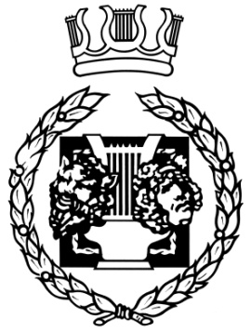
Group: Starburst
Show: Snow White and the Seven Dwarfs
Venue: The Harlington Centre, Fleet
Date: 15 December 2016
Director: Ricky Cale
Producers: Max Topliss & Shaun “Lofty” Garrett
Choreographer: Liz Woodford
Musical Director: Paul Darrah

Snow White and the Seven Dwarfs by Stephen Duckham is a pantomime about how the wicked Queen Malevolent rules the village and the life of the beautiful and loved Snow White. She is fuelled by jealousy of Snow White’s beauty and seeks to destroy her. Charming and brave Prince Rupert enters the scene and there then follows a journey of fun, songs, dances and the inevitable happy ending as good overcomes evil and the happy couple find true love and live happily ever after.

Front of House: The front of house team welcomed patrons and helped to create the atmosphere ready for the production.

Theatre ambience: There was a nice, lively and happy atmosphere and an air of excitement on the first night of the production.

The programme: The programme – an excellent, glossy A4 gave clear information about the history of the group, the production, cast and crew, lovely rehearsal photos.

Scenery/Set/Properties The sets were very realistically created with beautifully painted flats: the Royal Palace, the Village, the Forest and so on. The set dressings were all appropriate and well chosen and the props were well used by the cast.

Hair and Make -up: The make-up was outstanding. Queen Malevolent’s hair and make-up emphasised her wickedness and contrasted well with Snow White’s traditional black wig. Dame Doitall’s make up (electric blue) deserves special praise. His wigs were also outstanding.

Costumes: The costumes were fantastic and of high quality. There was great attention to detail. The Dame had suitably outlandish outfits and wore them with a flourish. Overall the costumes were bold but well balanced.

Lighting and Sound Effects: The lighting was effective throughout and well controlled. The sound was excellent with voices clear and blending well with the live music.

The Production: Directed by Ricky Cale, this outstanding production was traditional panto as well as keeping the modern generation happy with some high tech (Magic Mirror) and modern pizzazz. There were sumptuous sets and costumes, a terrifically wicked Queen who cackled with malevolence and the comic banter from Daryl Quick as Dame Dotitall was supremely executed. Alex Barron produced some magic and was perfectly cast in the title role as was Lynne Main as Queen Malevolent. Ben Lee played Prince Rupert with just the right amount of smarm and charm and Hannah Norman and Aiden Dunlop as the hapless pair, Handy and Andy bounced off each other (literally) brilliantly. The dwarfs were all utterly delightful. The choreography was first class and the fights and falls were ingenuous. It takes a lot of hard work and effort on and off the stage to produce such a high class show and Ricky brought together the various elements with flair and panache. There was never a dull moment: the whole evening was bursting with energy, leaving the audience with huge smiles on their faces. It is impossible to single out what really made this show special – it was everything!

A short version of this report will appear on the NODA website in due course.

Chris Horton
District 14 Regional Representative

